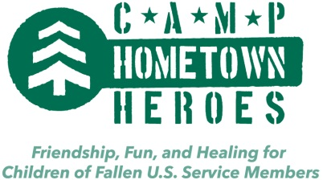
Spring 2013
Dear Prospective Camp Families:
This summer dozens of children will have the unique opportunity to make friends, have fun, and if desired, speak openly about the loss of a loved one. Camp Hometown Heroes is a week-long overnight summer camp that will take place at YMCA Camp Matawa in Campbellsport, Wisconsin from June 22-28th. The camp is specifically designed for the children and younger siblings (ages 7-16 suggested) of fallen U.S. service members who died in any manner. Through the generosity of our sponsors, Camp Hometown Heroes is provided entirely free of charge.
In 1991, I met a five year old boy who was living with AIDS. While physically he was healthy and growing, emotionally he was doing very poorly as he was the subject of discrimination and cruelty. His experiences as a young boy provided the inspiration to create Camp Heartland, the nation’s first summer camp exclusively for children affected by HIV/AIDS. After serving as Founder and CEO of Camp Heartland (now called One Heartland) for nearly 20 years I saw time and time again the significant impact this summer camp made on children who were grieving, hurting and often alone.
While the background circumstances may be different for the children and siblings of fallen U.S. service members, I know that Camp Hometown Heroes will make a similar impact for your child. Imagine an environment, where your child can find support, acceptance, friendship and if desired, many opportunities for healing and growth. This environment is Camp Hometown Heroes!
Camp Hometown Heroes is built on a partnership between a number of leading non-profit organizations who have decades of service to military families, grieving children and in summer camp leadership. We take our responsibility to your children very seriously and ensure a safe environment through thorough background checks, training and volunteer management. Camp Hometown Heroes is a warm, caring environment where at long last, children can be with other kids who can relate to their personal stories.
The presenting financial sponsor of Camp Hometown Heroes is Kapco, Inc. The program will be operated by YMCA Camp Matawa and Kyle’s Korner, a charity that specializes in helping children grieve and heal. Our friends at Hope for the Warriors® and Being There - Reaching Out are partnering with us to identify families like yours that would qualify for this free summer camp session. I know your child will thoroughly enjoy traditional summer camp activities such as swimming, fishing, rock climbing, archery, arts & crafts and campfires. But moreover, I know they will gain from a very supportive and healing environment. Please contact me at 262-377-6500 #215 with any questions about our camp program, registration or other topics.
Very best wishes,
Neil Willenson
Co-Founder

Enclosed: Brochure, Pre-Registration Form, Leadership Team Biographies, Typical Daily Schedule

